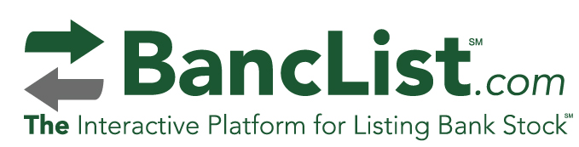
Important Announcement About Your BancList Service
The anonymity feature of the BancList service is designed to protect your identity when you create a listing of intent to buy or sell stock. It is strongly recommended, however, that both parties to a potential transaction provide some form of identification to each other in the event the shareholder who created the original listing receives a response that he/she believes may lead to a potential transaction. See example below. This will avoid confusion about a party’s identification. Remember, no transaction has been created or finalized until the bank has reviewed all information from both parties. Thank you.
I. Sample Response to a Listing
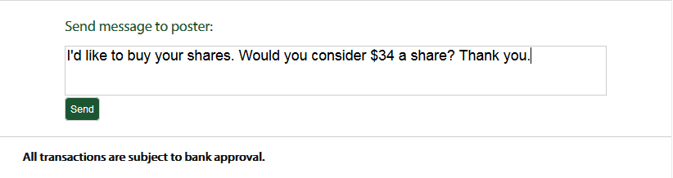
II. Response From Shareholder Who Created Listing
